Retrieving Data Using the SQL SELECT Statement

1. Determine the Structure of DEPT Table and its Contents.
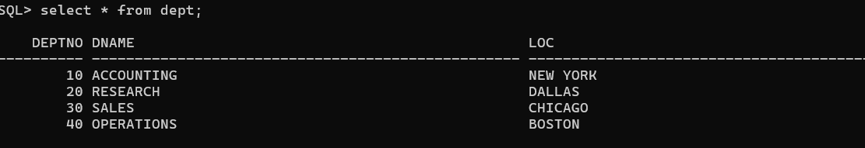

2. Determine the Structure of EMP Table and its Contents.

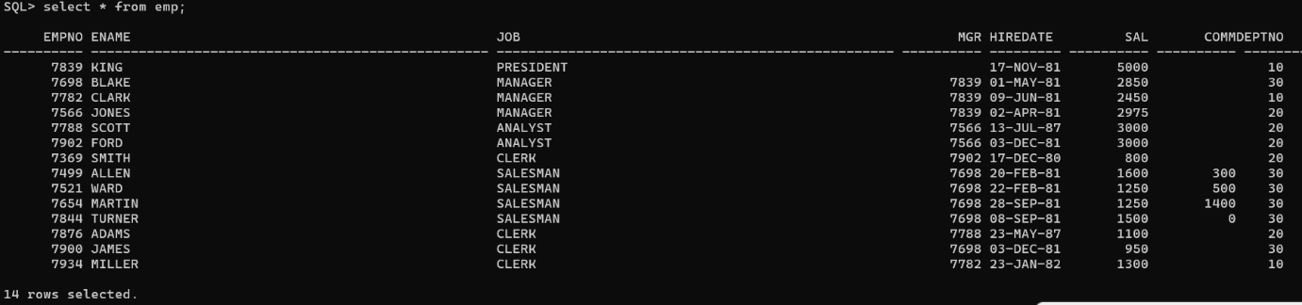

3. Display the Ename and Deptno from Emp table whose Empno is 7788.
